PERSONAL FINANCE MANAGER
Software Design Document
Clean Architecture + SOLID Design Principles

Subject:
Object-Oriented Analysis and Design

1. Overview
The Personal Finance Manager is a console-based C++ application that enables individuals to track their income, expenses, and budgets through an intuitive text interface. The system persists all financial data using SQLite, ensuring continuity across sessions.

The application manages the following core domains:
- Expenses – categorized spending records with date tracking
- Income – income records with source attribution
- Budgets – monthly spending limits per category with real-time tracking
- Financial Summaries – aggregated balance and category-wise breakdown

The system adheres strictly to Clean Architecture and SOLID design principles, enforcing a clear separation of concerns across four distinct layers: Domain, Application, Interface Adapters, and Infrastructure.

2. Goals and Objectives
The primary objectives of the Personal Finance Manager are:
Expense Management
- Add new expense records with category, amount, description, and date
- View all recorded expenses in a tabular format
- Filter expenses by category or date range
- Delete expense records by ID
Income Management
- Add income records with source, amount, and date
- View all income records
Budget Management
- Define monthly spending limits per category
- Track real-time budget usage and alert on overrun
Reporting
- Generate financial summaries: total income, expenses, balance
- Category-wise spending breakdown
Non-Functional Goals
- Data persistence using SQLite across application restarts
- Extensible design — new features added without modifying existing code
- Input validation before any business logic is executed

3. Architecture
The application follows Clean Architecture (also known as Onion Architecture), where dependencies always point inward — outer layers depend on inner layers, never the reverse.

Layer | Package | Responsibility | Depends On
1 (innermost) | Domain (Entities) | Core business objects: Expense, Income, Budget, Category | Nothing (pure)
2 | Application (Use Cases) | Business rules; one use case class per operation | Domain only
3 | Interface Adapters | Controllers; translate user input to use case calls | Application interfaces
4 (outermost) | Infrastructure | SQLite repos, Console I/O, AppFactory (composition root) | All inner layers via interfaces

3.1 Dependency Rule
Source code dependencies always point inward. The Infrastructure layer knows about the Application layer's interfaces, but the Application layer knows nothing about SQLite, the console, or any concrete I/O. This allows the database or UI to be swapped without touching business logic.

3.2 Component Summary
Domain Layer: Contains plain data classes (Expense, Income, Budget, BudgetStatus, FinancialSummary) and the Category enum. No external dependencies.
Application Layer: Contains repository port interfaces (IExpenseRepository, IIncomeRepository, IBudgetRepository) and 10 use case classes, each implementing exactly one operation interface (SRP + ISP).
Interface Adapters: Contains controllers (ExpenseController, IncomeController, BudgetController, SummaryController, MainMenuController) and I/O port interfaces (IInputHandler, IOutputHandler).
Infrastructure: Contains SQLite repository implementations, ConsoleInputHandler, ConsoleOutputHandler, and AppFactory — the sole composition root where concrete types are wired together.

4. Data Model
Entity | Field | Type | Constraint | Description
Expense | id | INTEGER | PRIMARY KEY AUTOINCREMENT | Unique identifier
 | amount | REAL | NOT NULL | Expense amount in currency
 | category | TEXT | NOT NULL | Category enum value
 | description | TEXT | OPTIONAL | User note
 | date | TEXT | NOT NULL | ISO date string YYYY-MM-DD
Income | id | INTEGER | PRIMARY KEY AUTOINCREMENT | Unique identifier
 | amount | REAL | NOT NULL | Income amount
 | source | TEXT | NOT NULL | Income source label
 | date | TEXT | NOT NULL | ISO date string
Budget | id | INTEGER | PRIMARY KEY AUTOINCREMENT | Unique identifier
 | category | TEXT | NOT NULL | Category enum value
 | limitAmount | REAL | NOT NULL | Monthly spending cap
 | month | TEXT | UNIQUE per category | Format: YYYY-MM

5. Database Schema
The application uses SQLite3 as its persistence engine. The schema is auto-initialized on first launch by SQLiteConnection::initializeSchema().

CREATE TABLE expenses ( id INTEGER PRIMARY KEY AUTOINCREMENT, date TEXT NOT NULL, category TEXT NOT NULL, amount REAL NOT NULL, description TEXT ); CREATE TABLE income ( id INTEGER PRIMARY KEY AUTOINCREMENT, date TEXT NOT NULL, source TEXT NOT NULL, amount REAL NOT NULL, description TEXT ); CREATE TABLE budgets ( id INTEGER PRIMARY KEY AUTOINCREMENT, category TEXT NOT NULL, limitAmount REAL NOT NULL, month TEXT NOT NULL, UNIQUE (category, month) );

6. UML Diagrams
The following diagrams collectively represent the system design from different perspectives: actor interactions, data flows, behavioral sequences, entity relationships, and class structure.

6.1 Use Case Diagram
The Use Case diagram identifies the system's actors and the high-level capabilities they can invoke. The primary actor is the User, who interacts with four groups of use cases: Expense Management, Income Management, Budget Management, and Financial Summary. Filter Expenses includes two sub-cases (By Category and By Date Range), modeled with «include» relationships.
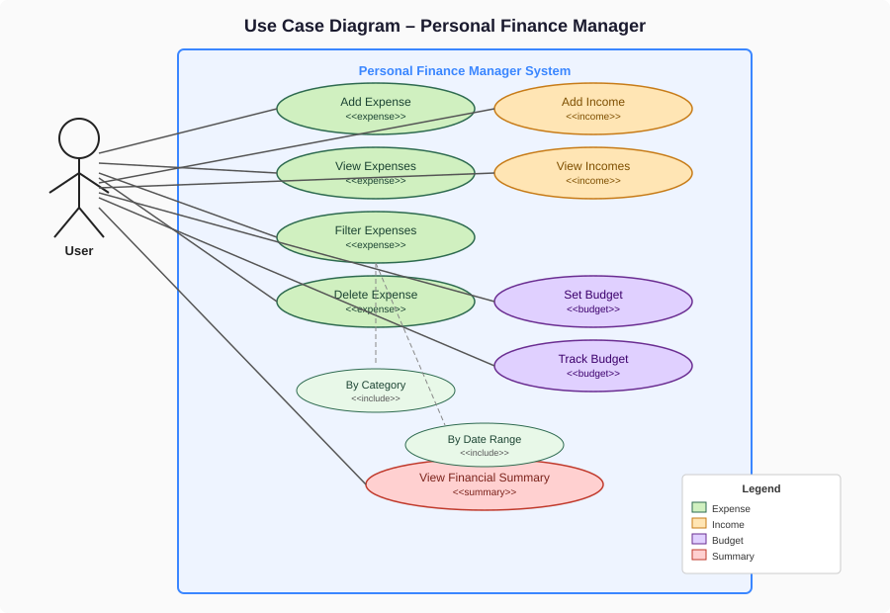
Figure 6.1 – Use Case Diagram

6.2 Flow Diagram
The Flow Diagram illustrates the runtime control flow of the application. The system initializes the SQLite database on startup, then enters the main menu loop. The user is routed to one of three sub-menus (Expense, Income, Budget) or a Summary view. After each operation, results are persisted to the database and displayed. The user may return to the main menu or exit.
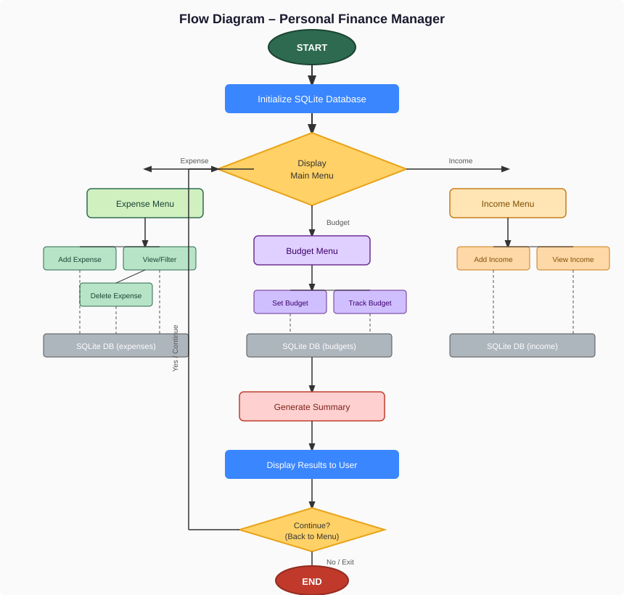
Figure 6.2 – Application Flow Diagram

6.3 Activity Diagram
The Activity Diagram details the behavioral flow for the Add Expense operation, organized as a swimlane diagram across three actors: User, Application (Controller), and Repository/Database. It shows input collection, validation with error feedback, domain object creation, database persistence, and confirmation display.
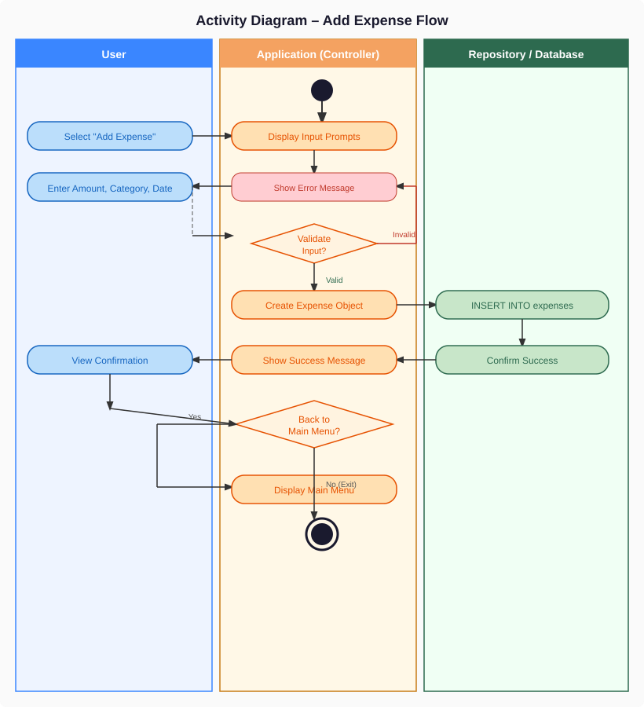
Figure 6.3 – Activity Diagram (Add Expense)

6.4 Entity-Relationship (ER) Diagram
The ER Diagram models the database schema and relationships between entities. Expense and Budget both carry a category field that references the Category enum (enforced at the application layer). The UNIQUE constraint on (category, month) in Budget ensures one budget per category per month. All primary keys use AUTOINCREMENT for surrogate key generation.
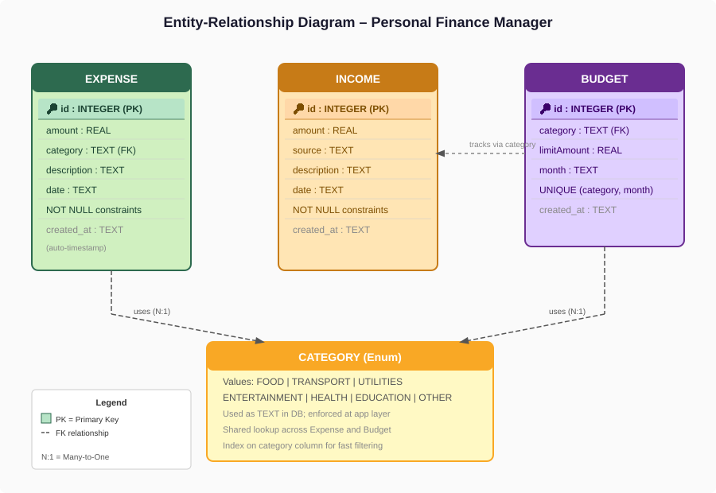
Figure 6.4 – Entity-Relationship Diagram

6.5 Class Diagram
The Class Diagram represents the full object-oriented design across all four architecture layers. It shows class attributes, methods, interface realizations (dashed arrow with hollow triangle), and dependency relationships (dashed arrow). The diagram demonstrates adherence to all five SOLID principles as annotated.
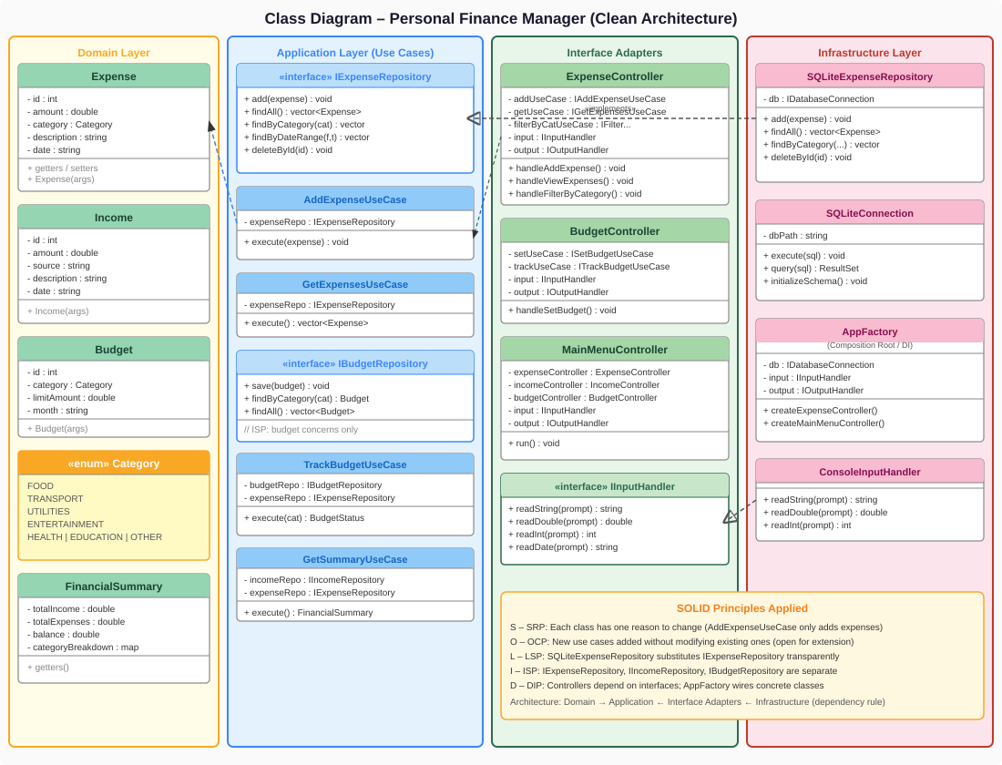
Figure 6.5 – Class Diagram (Clean Architecture + SOLID)

7. Design Principles
Principle | Acronym | How It Is Applied | Example
Single Responsibility | SRP | Each class has exactly one reason to change | AddExpenseUseCase only adds expenses; it never queries them
Open/Closed | OCP | New use cases are added as new classes, not by modifying existing ones | Adding DeleteExpenseUseCase doesn't touch GetExpensesUseCase
Liskov Substitution | LSP | Any IExpenseRepository implementation is fully substitutable | SQLiteExpenseRepository can be swapped for InMemoryExpenseRepository in tests
Interface Segregation | ISP | Interfaces are split by aggregate; no fat interfaces | IExpenseRepository, IIncomeRepository, IBudgetRepository are separate
Dependency Inversion | DIP | High-level modules depend on abstractions, not concretions | AddExpenseUseCase depends on IExpenseRepository; AppFactory wires SQLiteExpenseRepository
Separation of Concerns | SoC | UI, business logic, and persistence are fully independent layers | ConsoleInputHandler handles I/O; use cases never call cin/cout

8. Usage Notes

8.1 Startup
- The SQLite database file (finance.db) is auto-created on first launch
- SQLiteConnection::initializeSchema() creates all tables if they do not exist
- AppFactory wires all dependencies before the main menu is displayed

8.2 Expense Operations
- Expenses are categorized using the Category enum (FOOD, TRANSPORT, UTILITIES, ENTERTAINMENT, HEALTH, EDUCATION, OTHER)
- Filtering supports two modes: by category and by date range (YYYY-MM-DD format)
- Deletion is by expense ID, which is displayed in the view table

8.3 Budget Rules
- Budgets are defined per category per month (format: YYYY-MM)
- Only one budget can exist per category+month pair (UNIQUE constraint enforced)
- Setting a budget for an existing category+month replaces the previous entry
- TrackBudgetUseCase computes spent amount live by summing matching expenses

8.4 Summary
- Financial Summary reads all income and expense records from the database
- Reports: total income, total expenses, balance (income - expenses), and category-wise spending

8.5 Extensibility
- New data sources: implement IDatabaseConnection (e.g., PostgreSQLConnection) and inject into repositories — no business logic changes
- New UI: implement IInputHandler and IOutputHandler for GUI, web, or mobile — no controller changes
- New features: add a new use case interface + class pair and a new controller method — existing code untouched

9. Technology Stack
Component | Technology | Notes
Language | C++17 | Modern C++ with smart pointers and STL containers
Database | SQLite3 | Embedded, zero-config, single-file relational database
Architecture | Clean Architecture | Domain → Application → Adapters → Infrastructure
Design Patterns | Repository, Use Case, Factory, DI | Dependency injection via AppFactory composition root
Build System | CMake | Cross-platform build; links sqlite3 library
I/O | Console (stdin/stdout) | Abstracted via IInputHandler/IOutputHandler

